WEEK 3: SYSTEM DEVELOPMENT I

- INTENDED LEARNING OUTCOME (ILO)
At the end of this laboratory activity, students should be able to:
Develop and implement the core functionalities, user interfaces, and system workflows specified in the approved project requirements while applying established coding standards and collaborative development practices.

PERFORMANCE TASK
Following the successful completion of the development environment setup and database implementation during Week 2, your team shall begin actual system development.
You are required to implement the project's priority features, develop user interface components, and establish system workflows that demonstrate the project's core functionality.
The outputs produced this week will serve as evidence that the project has transitioned from planning to actual software development.

WEEK 3 ACTIVITIES
Activity 1 – Module Development Planning Activity 2 – Core Functionality Development Activity 3 – User Interface Development Activity 4 – Workflow Configuration
Activity 5 – Internal Functionality Verification Activity 6 – Repository Update and Version Control
Activity 7 – Progress Reporting and Adviser Consultation

Purpose

ACTIVITY 1
MODULE DEVELOPMENT PLANNING

To identify and prioritize the modules that will be developed during Week 3.

Procedure
  - Review the approved requirements specification.
  - Review the Work Breakdown Structure (WBS).
  - Identify priority modules for development.
  - Assign responsibilities among team members.
  - Complete Form 1.

FORM 1
WEEK 3 MODULE DEVELOPMENT PLAN

Directions
List all modules scheduled for development this week.
Module | Description | Assigned Member | Target Completion
User Authentication | Login and logout with bcrypt password hashing, session management, CSRF protection and login rate limiting. | Bueno, Jannces G. | August 8, 2026
Packet Capture | Continuous background capture of ARP, TCP, UDP, DHCP and mDNS traffic using Scapy and Npcap. | Bueno, Jannces G. | August 8, 2026
Threat Detection Engine | Detection of MITM, ARP poisoning, MAC spoofing, port scanning and rogue DHCP, with active confirmation. | Bueno, Jannces G. | August 8, 2026
Device Monitoring | Live device registry with connect, disconnect and reconnect detection within 6 to 10 | Attaban, Quincy Joy B. | August 8, 2026
Dashboard Interface | Administrator dashboard with summary cards, six tabbed panels, live charts and real-time updates. | Gulla, Ma. Leonora M. | August 8, 2026
Public Status Page | Login-free network safety page showing a SAFE / CAUTION / THREATS DETECTED  verdict to any device on the Wi-Fi. | Gulla, Ma. Leonora M. | August 8, 2026
Reporting Module | Threat, Connection, Device and Security Summary reports exported as CSV or PDF. | Attaban, Quincy Joy B. | August 8, 2026

Priority Classification
☑ High Priority
- Medium Priority
- Low Priority

Team Approval
Member Signatures:
Member Name | Signature
Bueno, Jannces G.
Attaban, Quincy Joy B.
Gulla, Ma. Leonora M.

ACTIVITY 2
CORE FUNCTIONALITY DEVELOPMENT

Purpose
To develop the major business processes and functions required by the project.

Examples
Depending on project type:
- User Registration
- User Authentication
- Records Management
- Inventory Processing
- Appointment Scheduling
- Reporting Module
- Data Analytics Module
- Security Module

Procedure
- Develop assigned functionality.
- Apply approved coding standards.
- Test functionality locally.
- Commit source code to repository.
- Complete Form 2.

FORM 2
CORE FUNCTIONALITY DEVELOPMENT REPORT

Directions
Document each completed functionality.
Functionality | Description | Status
User Authentication | Administrator login and logout with bcrypt hashing (cost 12), 60-minute idle timeout, CSRF tokens on all state-changing requests, and lockout after 5 failed attempts. | Complete
Packet Capture | Background sniffer capturing ARP, TCP, UDP, DHCP and mDNS traffic with a kernel-level filter to reduce packet loss. | Complete
Threat Detection | Rule-based detection of five attack types with active confirmation and per-source deduplication to suppress false alarms. | Complete
Device Monitoring | Device registry recording MAC, IP, hostname, vendor and online status, with connect / disconnect / reconnect events logged. | Complete
Report Generation | Threat, Connection, Device and Security Summary reports exported as CSV or PDF and recorded in the reports table. | Complete

Functionality | Description | Status
Public Status Page | Unauthenticated safety page exposing only a verdict, counts and threat types — no device identifiers. | Complete

Functionality Verification
Test Conducted | Result
Input Validation | Pass
Process Execution | Pass
Output Generation | Pass

Evidence Attached
- Screenshot of Functionality
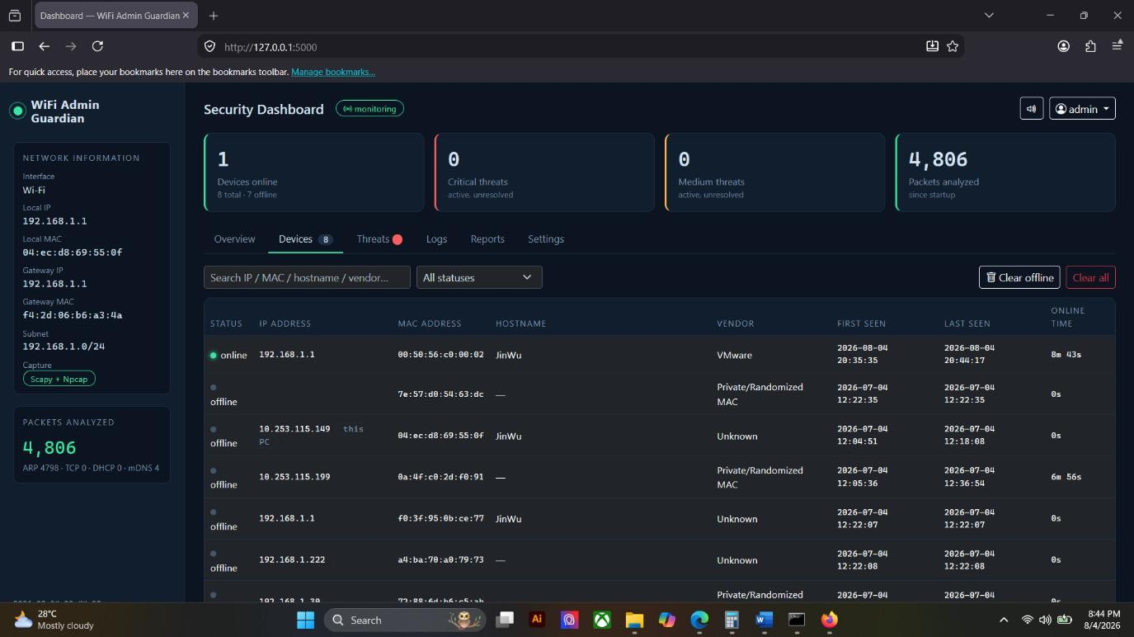

- Source Code Screenshot
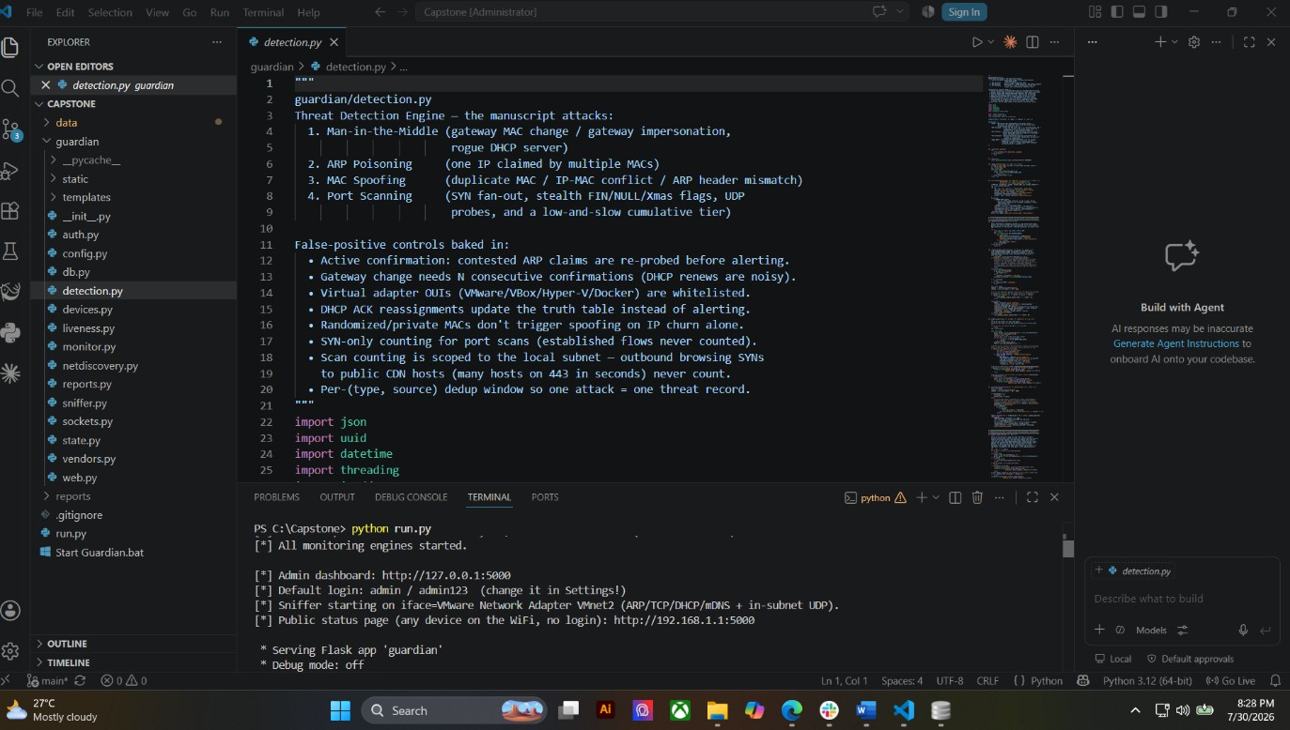
- Demonstration Screenshot
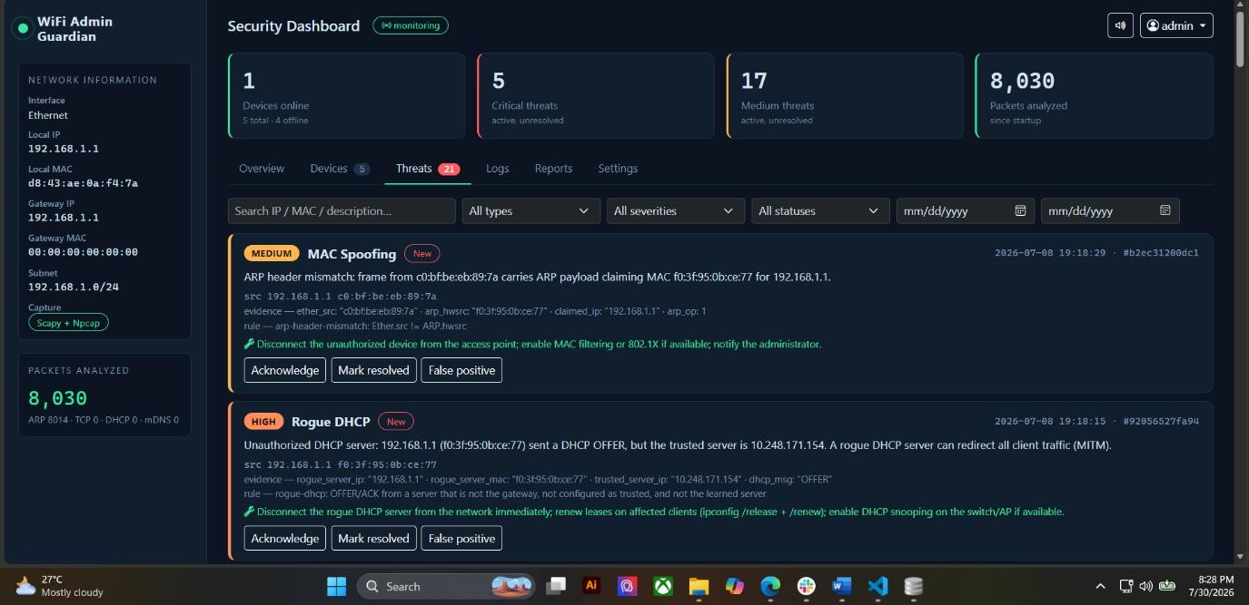

ACTIVITY 3
USER INTERFACE DEVELOPMENT

Purpose
To implement user-friendly interfaces aligned with approved system designs.

Procedure
- Develop system screens.
- Implement navigation menus.
- Apply usability principles.
- Verify screen responsiveness.
- Complete Form 3.

FORM 3
USER INTERFACE DEVELOPMENT REPORT

Directions
List all developed interfaces.
Interface/Page | Purpose | Status
Login Page | Administrator sign-in with server-side validation, CSRF protection and flash messaging. | Complete
Dashboard | Main monitoring screen with summary cards, live charts, activity feed and six tabbed panels. | Complete
User Management | Settings panel for administrator account management (password change) and monitoring configuration. The system currently uses a single administrator account; multi-user management is not part of the approved scope. | Complete
Reports Page | Report selection with CSV and PDF export, plus an export history table. | Complete

User Interface Checklist
Item | Completed
Consistent Design | ☑
Functional Navigation | ☑
Responsive Layout | ☑
Error Messages Implemented | ☑

Required Evidence
- Interface Screenshots

Login Page
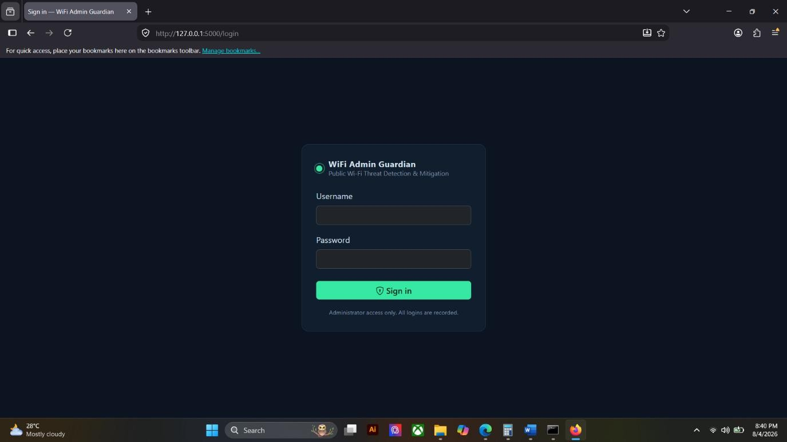

Dashboard
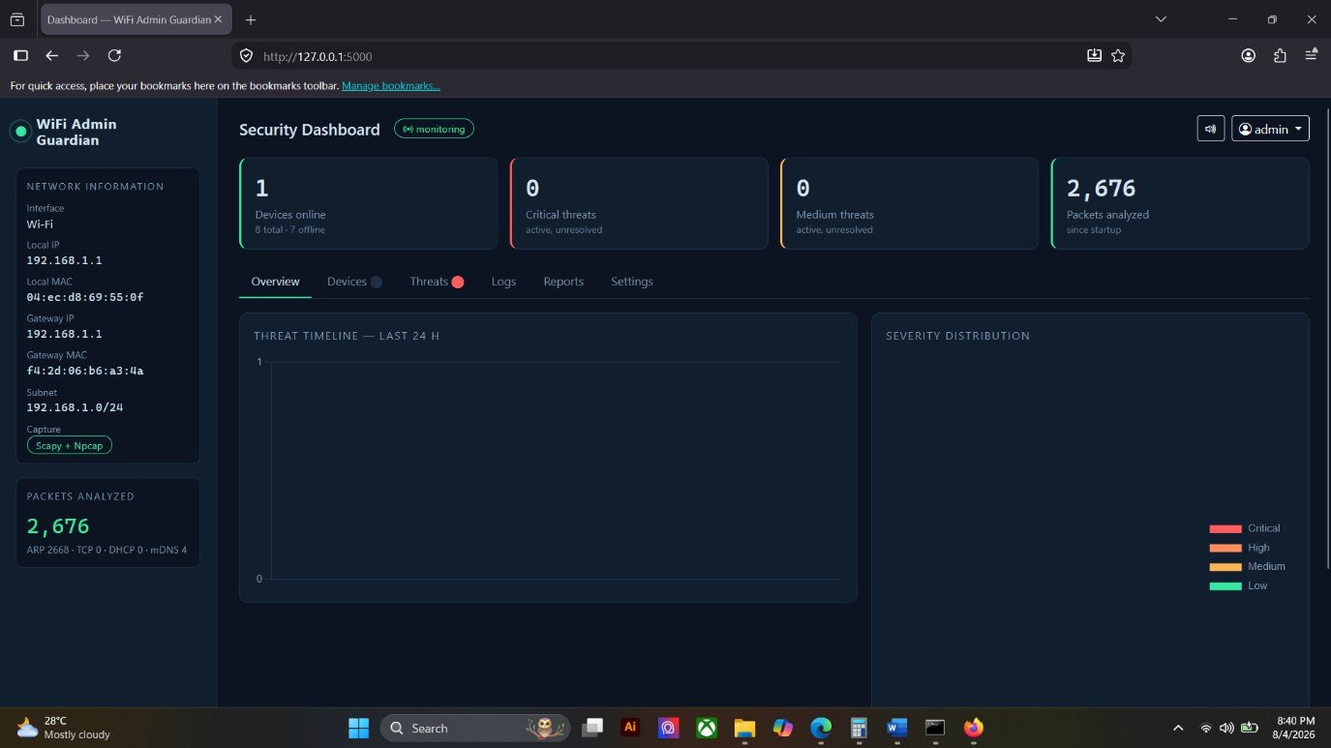

User Management
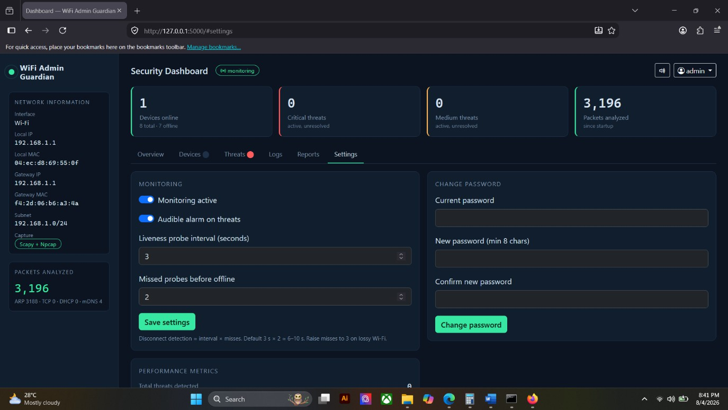

Reports Page
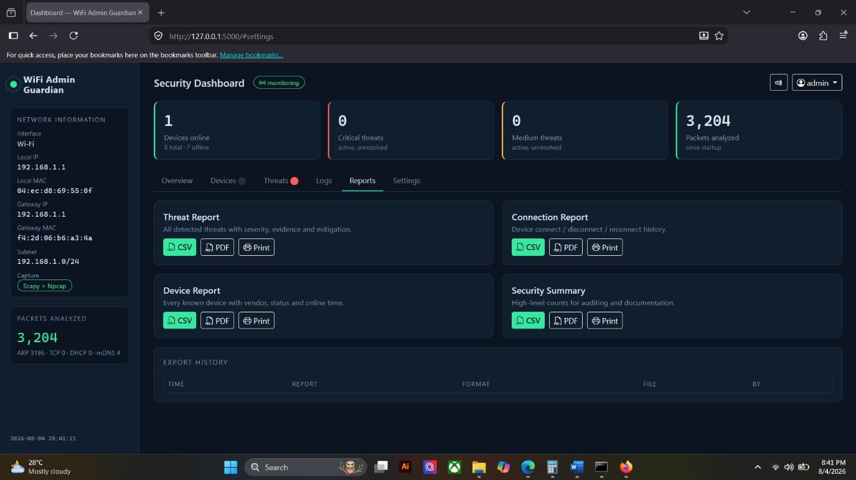

□ Navigation Demonstration

Devices Panel Active


Threats Panel Active
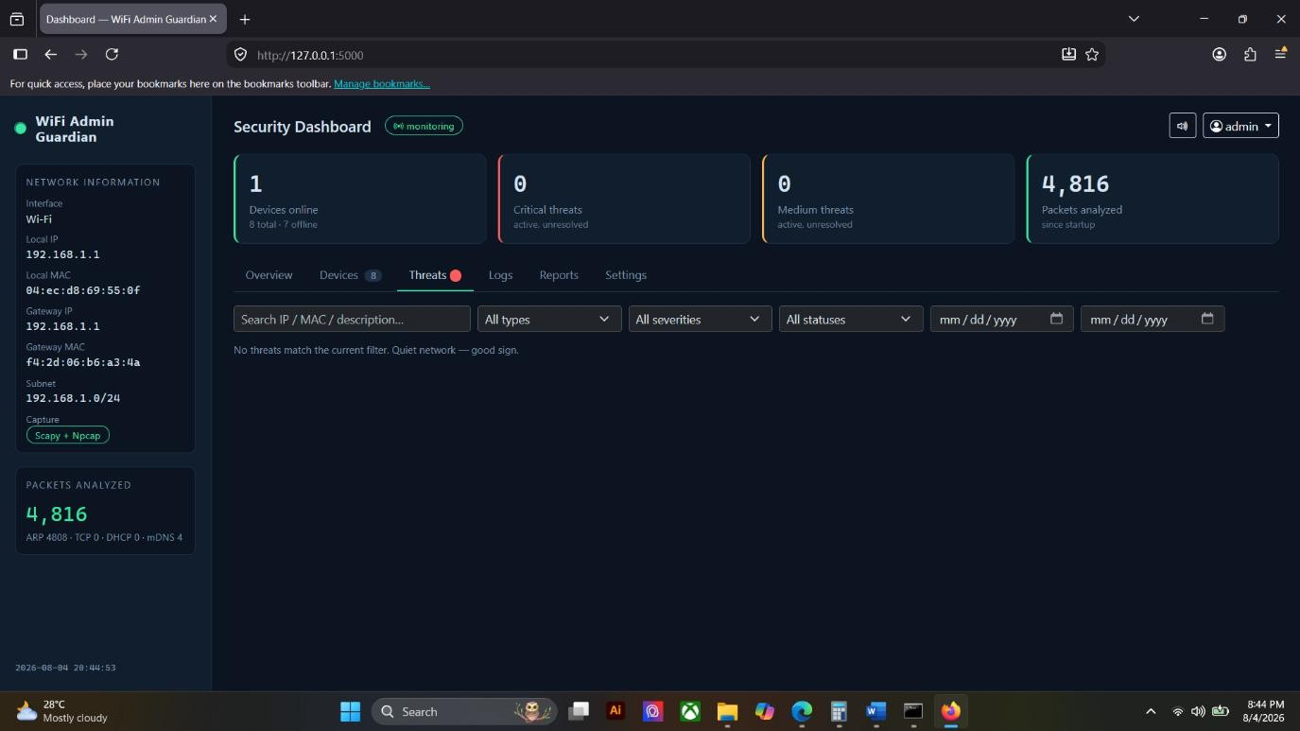

Settings Panel Active


ACTIVITY 4
SYSTEM WORKFLOW CONFIGURATION

Purpose
To establish the logical flow of system processes.

Procedure
  - Identify major transactions.
  - Configure workflow sequences.
  - Test process flow.
  - Verify system responses.
  - Complete Form 4.

FORM 4
SYSTEM WORKFLOW VALIDATION FORM

Directions
Document workflow implementation.
Workflow | Status | Remarks
Login Process | Implemented | Credentials verified with bcrypt; valid login creates a session, invalid login is logged and rate-limited.

Workflow | Status | Remarks
Data Entry Process | Implemented | Data enters automatically through packet capture rather than manual forms; administrator input is limited to settings and threat status updates.
Data Processing | Implemented | Captured packets are evaluated by the detection engine, confirmed by active re-probing, then stored and broadcast.
Report Generation | Implemented | Selected report queries the database,  builds a CSV or PDF file, records the export and returns the download.

Workflow Verification
Validation Item | Result
Inputs Accepted Correctly | Pass
Process Executes Correctly | Pass
Output Generated Correctly | Pass

Evidence Attached
- Workflow Diagram
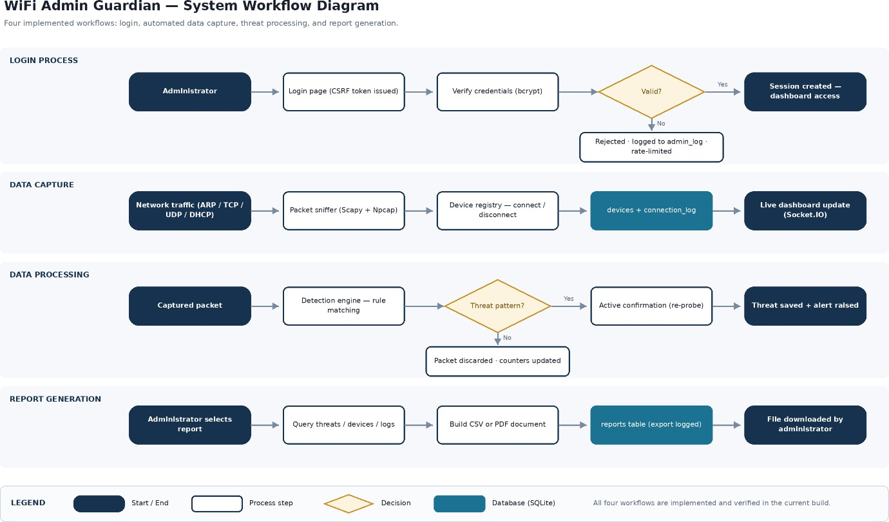

- Workflow Demonstration Screenshots

Workflow 1 – Login Process
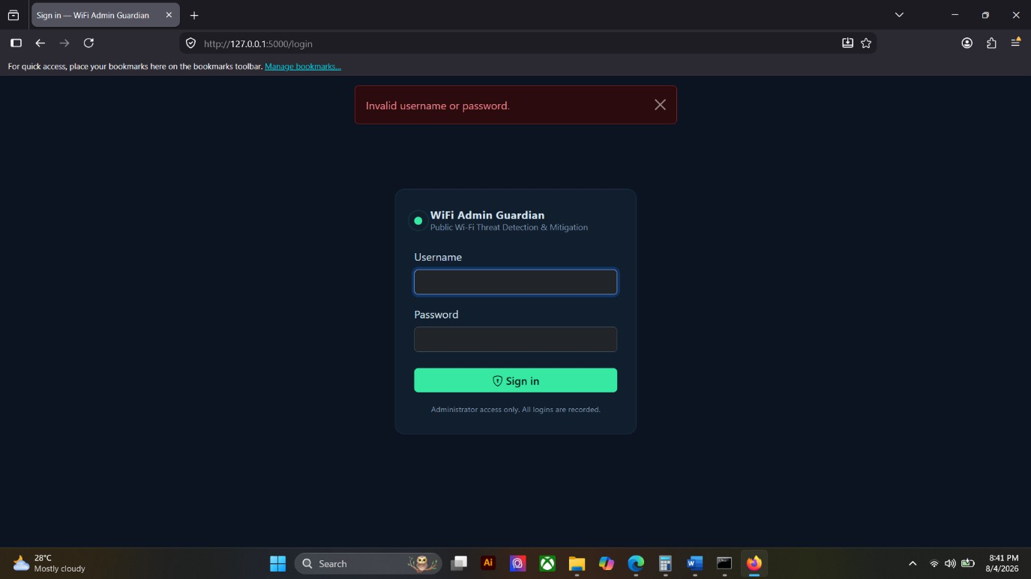

Workflow 2 – Data Capture



Workflow 3 – Data Processing
- Workflow 4.1 – Report Generation
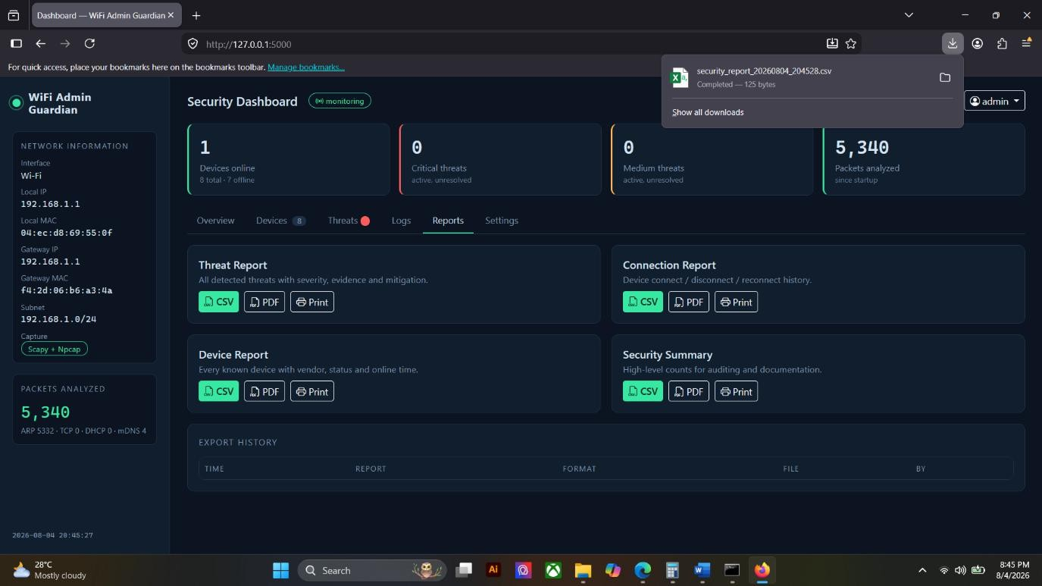

Workflow 4.2 – Output Verified
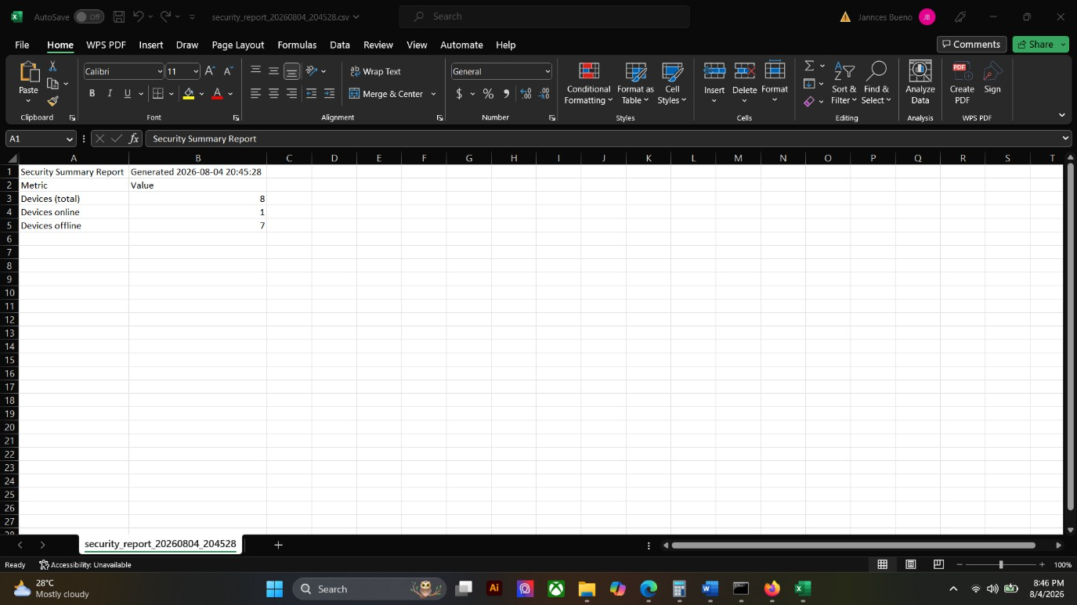

ACTIVITY 5
INTERNAL FUNCTIONALITY VERIFICATION

Purpose
To verify that developed modules are functioning properly before integration.

Procedure
  - Conduct peer testing.
  - Verify inputs and outputs.
  - Identify issues encountered.
  - Record findings.
  - Complete Form 5.

FORM 5
MODULE VERIFICATION CHECKLIST

Directions
Evaluate each completed module.
Module | Functioning Correctly | Needs Revision
User Authentication | ☑
Packet Capture | ☑
Threat Detection Engine |  | ☑
Device Monitoring | ☑

Module | Functioning Correctly | Needs Revision
Dashboard Interface | ☑
Public Status Page | ☑
Reporting Module | ☑

Issues Identified
Issue | Severity | Action Taken
Port-scan false positive: DNS replies from public resolvers (8.8.8.8 / 8.8.4.4) were counted as a UDP scan. | High | Fixed. Scan sources are now restricted to the local subnet, and packets from well-known service ports are treated as replies rather than probes.
Port-scan alerts mislabeled the scan direction (vertical vs. horizontal). | Medium | Fixed. Distinct ports and distinct hosts are now counted separately.
MAC Spoofing false positive: the router’s own second radio relaying ARP for a client was flagged as a spoofed frame. | Medium | Identified and reproduced. Fix scheduled for Week 4.
Rogue DHCP false positive: the monitoring machine’s VMware virtual adapter was flagged as an unauthorized DHCP server. | Medium | Identified and reproduced. Fix scheduled for Week 4.
Dashboard interface required an internet connection because libraries loaded from external CDNs. | Low | Fixed. Bootstrap, Chart.js and Socket.IO are now bundled locally and served by the application.

Team Verification
Test Conducted By:
    - Bueno, Jannces G.
    - Attaban, Quincy Joy B.
    - Gulla, Ma. Leonora M. Date: August , 2026

ACTIVITY 6 REPOSITORY UPDATE REPORT

Purpose
To document all development activities uploaded to the repository.

Procedure
- Commit all completed work.
- Update repository documentation.
- Record commits made.
- Complete Form 6.

FORM 6 REPOSITORY UPDATE REPORT
Repository URL: https://github.com/jannces/Capstone2

Commits Made This Week
Commit Description | Date
Add port-scan detection tiers, rogue-DHCP detector and database retention | August 2, 2026
Add sweep-time ARP truth check and mDNS device-name harvesting | August 2, 2026
Fix MITM false positive from the monitor’s own virtual adapters | August 2, 2026
Fix port-scan false positive on inbound DNS replies (8.8.8.8 / 8.8.4.4) | August 2, 2026
Fix scan labelling; serve dashboard assets locally instead of from CDNs | August 2, 2026
Add public network status page for all Wi-Fi users | August 2, 2026
Auto-configure Windows Firewall so Wi-Fi devices can reach the status page | August 2, 2026
Add one-click Windows launcher (Start Guardian.bat) | August 2, 2026
Add documentation and testing folders, plus requirements.txt | August 2, 2026

Repository Evidence
- Updated Source Code
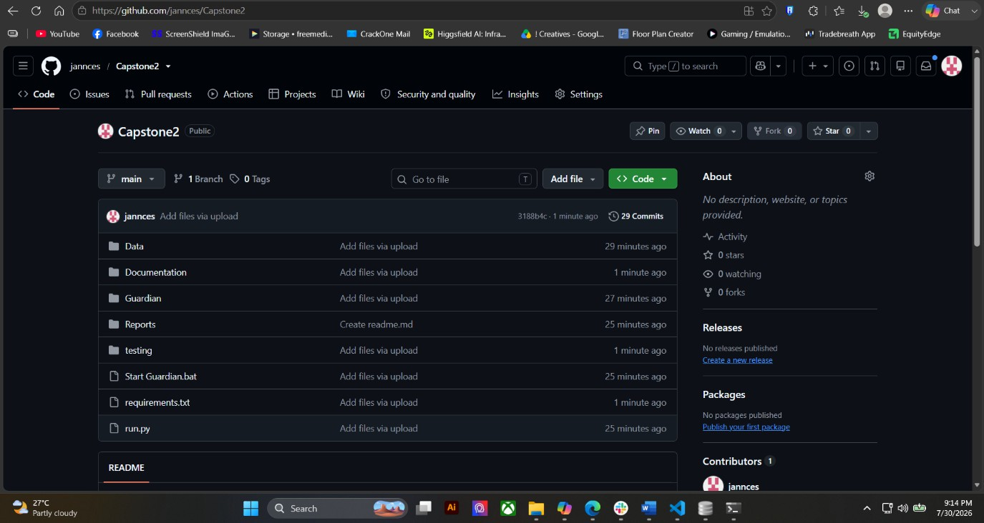

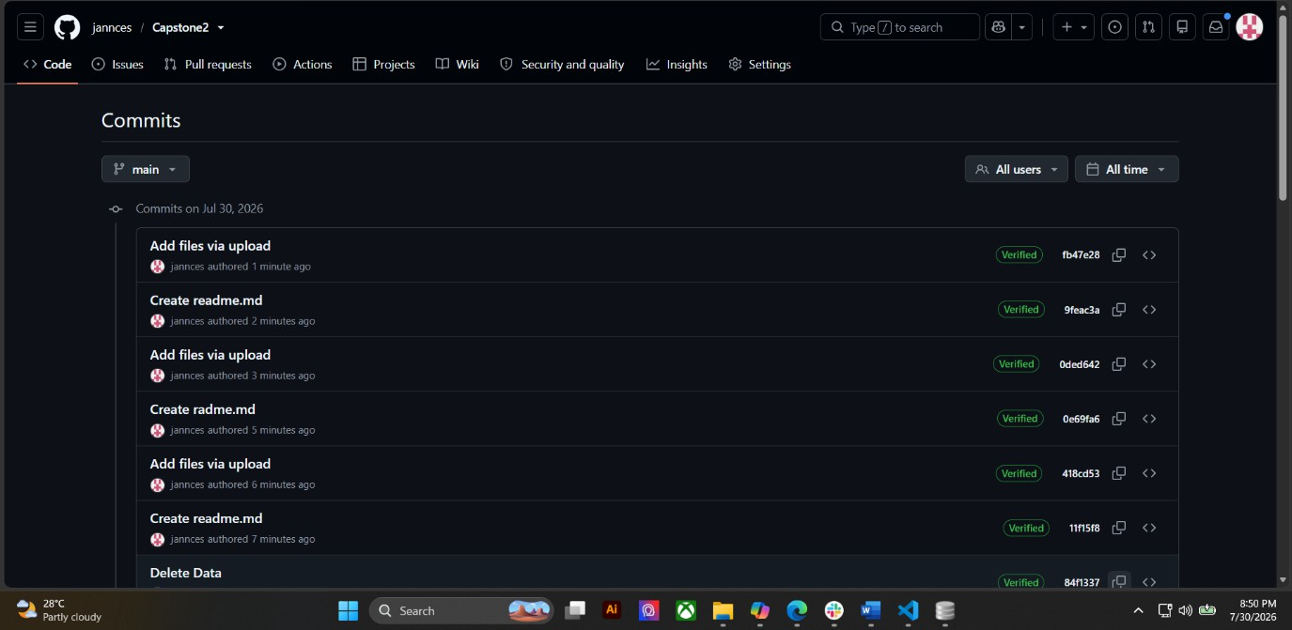
- Commit History Screenshot
- Branch Update Screenshot
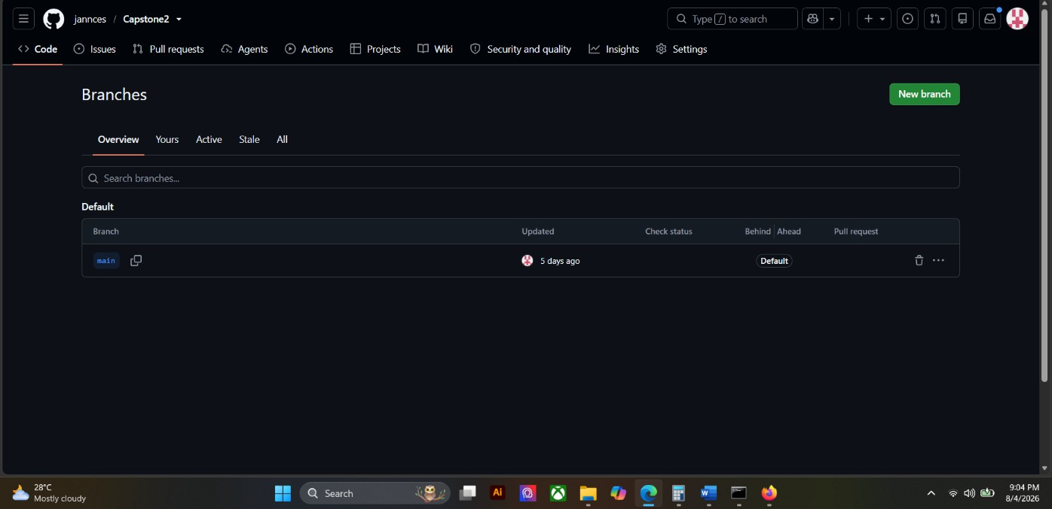

- Team Contributions Screenshot
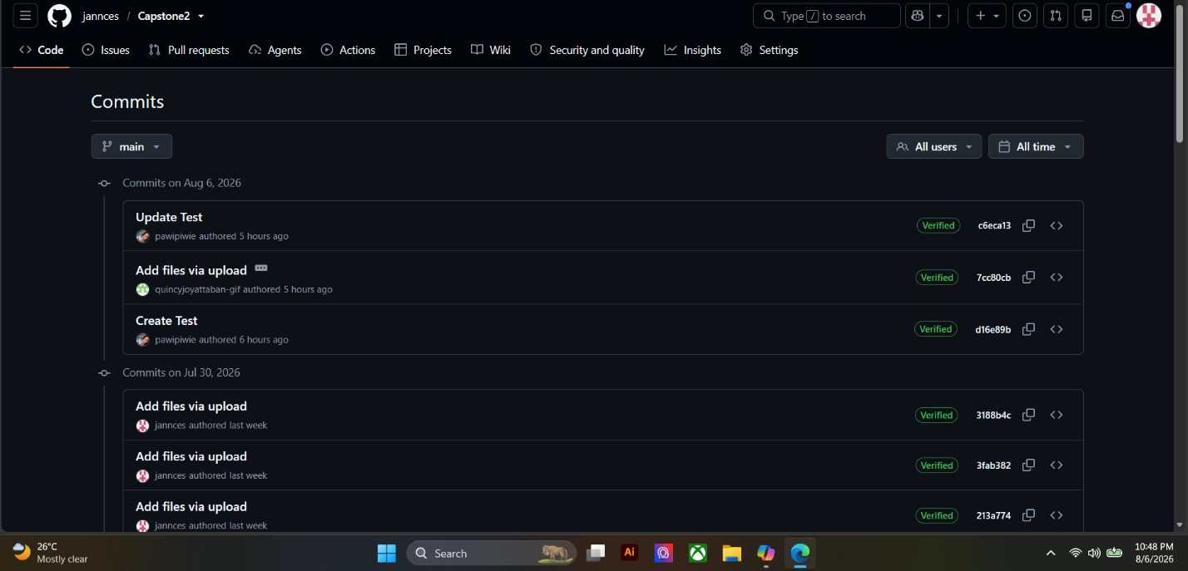

ACTIVITY 7 PROGRESS REPORT NO. 1

Purpose
To summarize development accomplishments during Week 3.

Procedure
- Review all completed activities.
- Summarize accomplishments.
- Identify challenges encountered.
- State plans for Week 4.
- Complete Form 7.

FORM 7 PROGRESS REPORT NO. 1

Project Information
Project Title: Wi-Fi Admin Guardian — Public Wi-Fi Threat Detection and Mitigation System

Date Submitted: August , 2026

Accomplishments This Week
Activity | Status
Core Functionality Development | Completed
User Interface Development | Completed
Workflow Configuration | Completed

Major Accomplishments
- Completed seven core modules: authentication, packet capture, threat detection, device monitoring, dashboard, public status page and reporting.
- Implemented detection for five attack types — MITM, ARP poisoning, MAC spoofing, port scanning and rogue DHCP — each with active confirmation before an alert is raised.
- Achieved device connect and disconnect detection within approximately 6 to 10 seconds.
- Delivered the administrator dashboard with live updates and the login-free public status page for ordinary Wi-Fi users.
- Completed all four system workflows: login, automated data capture, threat processing and report generation.
- Established an automated test suite of 51 tests covering detection accuracy, access control and the database layer.

Challenges Encountered
- False positives from normal network behavior — public DNS replies, the router’s own second radio, and the monitoring machine’s virtual adapters were incorrectly flagged as attacks.
- Distinguishing legitimate infrastructure traffic from genuine attacks, since several benign patterns are technically identical to attack signatures.
- The dashboard originally required an internet connection because its libraries loaded from external CDNs.
- Devices on the Wi-Fi could not reach the public status page because Windows Firewall blocked incoming connections by default.

Corrective Actions Taken
- Restricted port-scan detection to sources inside the local subnet and excluded replies from well-known service ports, removing the public DNS false positive.
- Corrected the scan classification logic so distinct ports and distinct hosts are counted separately.
- Bundled Bootstrap, Chart.js and Socket.IO locally so the interface works without internet access.
- Added an automatic firewall rule at startup so devices on the Wi-Fi can reach the public status page.
- Documented the two remaining false positives and scheduled their fixes for Week 4.

Planned Activities for Week 4
- Resolve the two remaining false positives (router-radio ARP relay and virtual-adapter DHCP).
- Conduct controlled attack simulations to measure detection accuracy and false-positive rate.
- Improve report content and add filtering options for the export module.
- Expand the automated test suite to cover the newly corrected detection rules.
- Begin integration testing of all modules and prepare for system testing.

Prepared by: | Reviewed by:
Bueno, Jannces G. | Dr. Romero Dante C. Salum
Group Leader | Project Adviser

FORM 8
ADVISER CONSULTATION RECORD

Directions
Present all Week 3 outputs and secure adviser feedback.
Topic Discussed | Recommendation
Module Development
User Interface Development
Workflow Implementation
Repository Progress

Adviser Remarks

Adviser Signature: Date: August , 2026

V. REQUIRED SUBMISSION
- Form 1 – Module Development Plan
- Form 2 – Core Functionality Development Report
- Form 3 – User Interface Development Report
- Form 4 – System Workflow Validation Form
- Form 5 – Module Verification Checklist
- Form 6 – Repository Update Report
- Form 7 – Progress Report No. 1
- Form 8 – Adviser Consultation Record
- Screenshots and Supporting Evidence

VI. WEEK 3 DELIVERABLES
- Progress Report No. 1
- Functional Core Modules
- Initial User Interfaces
- Workflow Implementation
- Updated Source Code Repository

